P1. True or false?

* a. A user requests a Web page that consists of some text and three images. For this page, the client will send one request message and receive four response messages.
  + False
* b. Two distinct Web pages (for example, www.mit.edu/research.html and www.mit.edu/students.html ) can be sent over the same persistent connection.
  + True
* c. With nonpersistent connections between browser and origin server, it is possible for a single TCP segment to carry two distinct HTTP request messages.
  + False
* d. The Date: header in the HTTP response message indicates when the object in the response was last modified.
  + False
* e. HTTP response messages never have an empty message body
  + False

P3. Consider an HTTP client that wants to retrieve a Web document at a given URL. The IP address of the HTTP server is initially unknown. What transport and application-layer protocols besides HTTP are needed in this scenario?

1. DNS - to get the name/ip of the unknown server.
2. TCP - to establish a connection with server and client.
3. HTTP - to load the html page.

P7. Suppose within your Web browser you click on a link to obtain a Web page. The IP address for the associated URL is not cached in your local host, so a DNS lookup is necessary to obtain the IP address. Suppose that ***n*** DNS servers are visited before your host receives the IP address from DNS; the successive visits incur an RTT of RTT1, … RTTn. Further suppose that the Web page associated with the link contains exactly one object, consisting of a small amount of HTML text. Let RTT0 denote the RTT between the local host and the server containing the object. Assuming zero transmission time of the object, how much time elapses from when the client clicks on the link until the client receives the object?

Time to get IP Address: RTT1 + RTT2 + RTT3 + ….. RTTn

+RTT0 (to set up TCP connection)

+RTT0 (to receive object)

Total Time = 2RTT0 + RTT1 + RTT2 + RTT3 + ….. RTTn

P8. Referring to Problem P7, suppose the HTML file references eight very small objects on the same server. Neglecting transmission times, how much time elapses with

* a. Non-persistent HTTP with no parallel TCP connections?

2RTT0 + (8*2RTT0) + RTT1 + RTT2 + RTT3 + ….. RTTn

= 18RTT0 + RTT1 + RTT2 + RTT3 + ….. RTTn

* b. Non-persistent HTTP with the browser configured for 5 parallel connections?

*** 5 connections can do 8 objects in 2 traversals.

2RTT0 + (2*2RTT0) + RTT1 + RTT2 + RTT3 + ….. RTTn

= 6RTT0 + RTT1 + RTT2 + RTT3 + ….. RTTn

* c. Persistent HTTP?

*** A new connection is not opened. Object are continuously sent.

2RTT0 + (RTT0) + RTT1 + RTT2 + RTT3 + ….. RTTn

= 3RTT0 + RTT1 + RTT2 + RTT3 + ….. RTTn

P9. Consider Figure 2.12 , for which there is an institutional network connected to the Internet. Suppose that the average object size is 850,000 bits and that the average request rate from the institution’s browsers to the origin servers is 16 requests per second. Also suppose that the amount of time it takes from when the router on the Internet side of the access link forwards an HTTP request until it receives the response is three seconds on average (see Section 2.2.5). **Model the total average response time as the sum of the average access delay** (that is, the delay from Internet router to institution router) **and the average Internet delay**. For the average access delay, use where Δ/(1-Δ𝛃) is the average time required to send an object over the access link and b is the arrival rate of objects to the access link.

* a. Find the total average response time.

Transmit time = L/R 15Mbps = 15,000,000bits/sec

Δ = (850,000bits/request) / (15,000,000bits/sec) = .0567sec/req

Traffic Intensity = Δ𝛃 = (.0567sec/req) * (16req/sec) = .9072

Average Delay = Δ/(1-Δ𝛃) = (.0567sec/req) / (1 - .9072) = 0.611sec

Total Average Response Time = Average Delay + HTTPResponseTime = 3sec + 0.611sec = 3.611sec

* b. Now suppose a cache is installed in the institutional LAN. Suppose the miss rate is 0.4. Find the total response time.

Average Delay = Δ/(1-Δ𝛃) = (.0567sec/req) / (1 - (.4* .9072)) = 0.089sec

Total Average Response Time = Average Delay + HTTPResponseTime = 3sec + 0.089sec = 3.089sec

However, 60% are satisfied almost immediately because of the cashed data.

Total Average Response Time = (60% * 0sec) + (40% * 3.089sec) = 1.2356sec

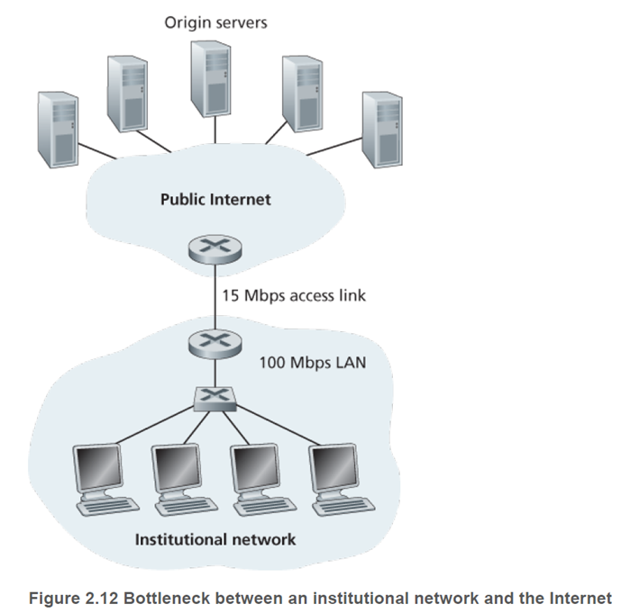

P22. Consider distributing a file of **F=15Gbits(15*1024Mbits) to *N* peers**. The server has an upload rate of **us=30Mbps**, and each peer has a **download rate of di=2Mbps** and an **upload rate of u.** For n=10,100, and 1,000 and u=300(0.2929Mbits), 700 Kbps(0.6835Mbits), and 2 Mbps, prepare a chart giving the minimum distribution time for each of the combinations of N and u for both client-server distribution and P2P distribution.

dmin - user with lowest download rate, **F=15Gbits(15*1024Mbits) = 15360Mbits**

Client-Server Min Distribution: Dcs ≥ max(NF/us , F/dmin)

n=10,u=300Kbps max(10*15360/30 , 15360/2Mbps) = 7,680

n=10,u=700Kbps max(10*15360/30 , 15360/2Mbps)

n=10,u=2Mbps max(10*15360/30 , 15360/2Mbps)

n=100,u=300Kbps max(100*15360/30 , 15360/2Mbps) = 51,200

n=100,u=700Kbps max(100*15360/30 , 15360/2Mbps)

n=100,u=2Mbps max(100*15360/30 , 15360/2Mbps)

n=1000,u=300Kbps max(1000*15360/30 , 15360/2Mbps) = 512,000

n=1000,u=700Kbps max(1000*15360/30 , 15360/2Mbps)

n=1000,u=2Mbps max(1000*15360/30 , 15360/2Mbps)

P2P Min Distribution: DP2P ≥ max(F/us, F/dmin , NF / (us + 𝝨Ni=1 ui) )

n=10,u=300Kbps max(15360/30, 15360/2Mbps, 10*15360/30 + 10*.2929) = 7680

n=10,u=700Kbps max(15360/30, 15360/2Mbps, 10*15360/30 + 10*.6835) = 7680

n=10,u=2Mbps max(15360/30, 15360/2Mbps, 10*15360/30 + 10*2) = 7680

n=100,u=300Kbps max(15360/30, 15360/2Mbps, 100*15360/30 + 100*.2929) = 25906.6

n=100,u=700Kbps max(15360/30, 15360/2Mbps, 100*15360/30 + 100*.6835) = 15617.7

n=100,u=2Mbps max(15360/30, 15360/2Mbps, 100*15360/30 + 100*2) = 7680

n=1000,u=300Kbps max(15360/30, 15360/2Mbps, 1000*15360/30 + 1000*.2929) = 47568.9

n=1000,u=700Kbps max(15360/30, 15360/2Mbps, 1000*15360/30 + 1000*.6835) = 21527.7

n=1000,u=2Mbps max(15360/30, 15360/2Mbps, 1000*15360/30 + 1000*2) = 7680

N - Client/Server

| u | 10 | 100 | 1000 |
| --- | --- | --- | --- |
| 300kbps | 7680 | 51200 | 512000 |
| 700kbps | 7680 | 51200 | 512000 |
| 2Mbps | 7680 | 51200 | 512000 |

N - P2P

| u | 10 | 100 | 1000 |
| --- | --- | --- | --- |
| 300kbps | 7680 | 25906.6 | 47568.9 |
| 700kbps | 7680 | 15617.7 | 21527.7 |
| 2Mbps | 7680 | 7680 | 7680 |

P26. Suppose Bob joins a BitTorrent torrent, but he does not want to upload any data to any other peers (so called free-riding).

* a. Bob claims that he can receive a complete copy of the file that is shared by the swarm. Is Bob’s claim possible? Why or why not?
  + It is possible. BitTorrent has a system called Optimistic Unchoking that allows users who are not in someone else’s top four to be randomly selected to download chunks from them. If Bob stayed in the swarm long enough he could be randomly selected enough times to gain all chunks.
* b. Bob further claims that he can further make his “free-riding” more efficient by using a collection of multiple computers (with distinct IP addresses) in the computer lab in his department. How can he do that?
  + Bob could set up each computer to “free-ride”. Each of them collects chunks of data through optimistic unchoking. Bob could then combine all the data chunks himself for a complete file. With enough computers with distinct IP addresses being randomly selected he could obtain all chunks within a reasonable time.

P27. Consider a DASH system for which there are N video versions (at N different rates and qualities) and N audio versions (at N different rates and qualities). Suppose we want to allow the player to choose at any time any of the N video versions and any of the N audio versions.

* a. If we create files so that the audio is mixed in with the video, so server sends only one media stream at given time, how many files will the server need to store (each a different URL)?
  + N files. Combining a video with audio in a 1-to-1 match.
* b. If the server instead sends the audio and video streams separately and has the client synchronize the streams, how many files will the server need to store?
  + 2N: A video and audio file for each pair has to be stored.

P30. Can you configure your browser to open multiple simultaneous connections to a Web site? What are the advantages and disadvantages of having a large number of simultaneous TCP connections?

Yes.

Advantage: More connections could result in faster downloads.

Disadvantage: Other users may experience slower downloads due to one person using a larger amount of bandwidth.

P32. What is the Apache Web server? How much does it cost? What functionality does it currently have? You may want to look at Wikipedia to answer this question.

What: Apache Web server is an open-source cross-platform web server software that is maintained by an open community of developers.

Cost: Free.

Functionality: Processes requests and serves web assets and content via HTTP. It is used in over 30% of all web applications and runs on the Linux operating system.